國立清華大學 生物醫學工程研究所

Multifunctional Beads as a Dual-Switched Drug Delivery System
(Title, Times New Roman 12, Bold)

Hsing-Wen Sung ^{*12}, Dehui Wan², Yunching Chen², and Zong-Hong Lin²
¹ Department of Chemical Engineering, National Tsing Hua University, Hsinchu 30013, Taiwan
² Institute of Biomedical Engineering, National Tsing Hua University, Hsinchu 30013, Taiwan
*hwsung@mx.nthu.edu.tw
Author*¹, Author², and Others² (Times New Roman 11, Bold) (underline the presenting author)
¹Affiliation, address (Centered, Times New Roman 11, Italics)
²Affiliation, address (Centered, Times New Roman 11, Italics)
(Corresponding author e-mail; Centered, Times New Roman 11)

Graduate Institute of Medical Engineering designs the curriculum to fit students from diverse backgrounds in order to fulfill the needs of medical engineering in the future. The Institute has 23 members of University faculty, full-time or jointly appointed from various departments. They are internationally well known in their individual fields such as biomaterials, drug delivery, tissue engineering and regenerative medicine, biosensing, biophotonics, industrial engineering and ergonomics. Many of them receive distinguished awards from the National Science Council and other foundations. In accordance to national development of biotechnology industry and the Hsinchu Biomedical Science Park, this institute integrates university-wise efforts to focus and engage in teaching, research and development of three important fields of medical engineering: nano-biomedical technology, tissue engineering and regenerative medicine, and intelligent biomedical systems. In nano-biomedical technology, the goal is to promote integrated research efforts in the forefront of biosensing, nano-materials, biophotonics and liver tissue chips. In tissue engineering and regenerative medicine field, we will put together technology in biomaterials, drug delivery, gene therapy and stem cell technology into integrated products or procedures. These will in turn promote applications in the regeneration of cardiovascular, cornea, neural, cartilage and bone tissues. Intelligent biomedical systems will combine materials, ergonomics and industrial engineering to focus on the development of novel treatment and health care systems, medical information systems, man-machine interfaces and medical devices that based on biomechanics, automation and biosensing technologies.
Please complete this abstract within 250 words.
The space between lines is 15-point in times new roman.

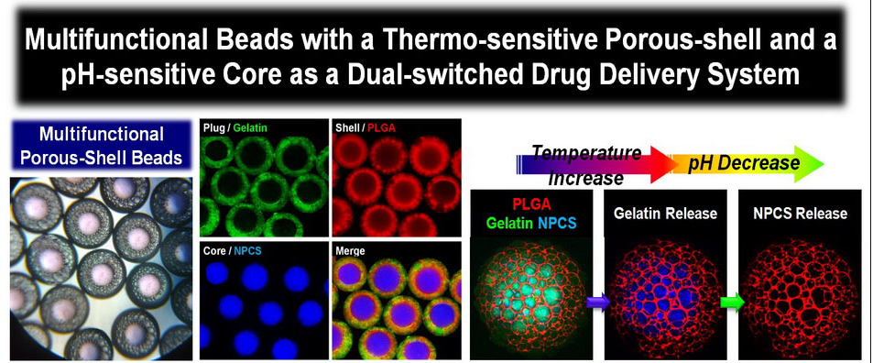
Please insert the table of contents/abstract graphics here. The use of color is encouraged.

References
1. K. Leong and H.-W. Sung, Adv. Drug Deliver. Rev., 65, 757 (2013).
2. Z.-X. Liao, Y.-C. Li, L.-M. Lu, and H.-W. Sung, Biomaterials, 35, 500 (2014).

Please condense all the contents to one page only!

